# INTRODUCTION

### Project Introduction:

A facial recognition system transmits accurate information with minimal human intervention and can reduce activities such as knocking friends with security features such as anti-counterfeiting, designed to detect and prevent attempts to bypass the system with photos or masks, one of the most common ways to steal a person's time. A cost-effective attendance management solution with fast facial recognition that can handle a large number of users is suitable for use in large organizations with many employees or residents or students. Technological developments are taking place in all fields to match the increasing pace of business. One such system that speeds up the attendance and admission process is the biometric attendance system.

Biometric identification is a method that measures the physical or behavioral characteristics of a person for identification purposes. In the past, passwords were the one of the available way to identify individuals. Passwords have expired due to password information being obtained and accounts being hacked. Biometric IDs have replaced passwords, which offer better protection and are not easily cracked compared to passwords. Many biometrics are used to participate; One widely used, safe and simple method is the facial recognition system. Biometric facial recognition is used all over our world. It is an advanced, automated and intelligent recognition system that can recognize a person by facial features. It uses a digital camera to record the facial image, a computer for processing and analysis, and a printing device to display the recognition result. Each person can be easily recognized by different facial images. The facial recognition system is a fast and reliable technology. This biometric is very secure because it identifies people without errors. Facial recognition is considered the first step towards application scenarios based on biometric access control, where biometric characteristics are extracted from people. This system is used in many institutes government agencies, companies, banks and other places.

### Scope:

Depending on the particular needs and goals of the organization or institution using the face recognition attendance system, the project's scope can change. However, the following common elements are often covered in the project scope of a face recognition attendance system: The overall system design, including the hardware and software elements necessary for the face recognition attendance system to operate, should be defined in the project scope. This covers camera specifications, algorithms for facial recognition, database administration, and user interface design. The system's functional needs, such as its capacity to accurately capture and recognize faces, provide attendance reports, and interact with current attendance systems, should be outlined in the project scope in unambiguous term

### Project Overview:

Participation is extremely important both for the teacher of the educational institution and for the student. Therefore, it is very important to keep records of attendance. The problem arises when you think about the traditional classroom participation process. Calling a student's name or number is not only a time-consuming problem, but also requires energy. So an automatic attendance system can solve all the above problems. Many facilities currently use some form of automated attendance system. One such system is biometric technology. Although it is automatic and a step ahead of the traditional method, it has no time limit. To participate, the student has to wait in line, which takes time. This project implements an inadvertent presence marking system, does not interfere with normal learning. The system can also be used in exam sessions or other learning activities where attendance is very important. This system eliminates classic student identification such as checking the student's caller name or the respective student's ID cards, which not only interrupts the ongoing learning, but can also be stressful for students during exam sessions. In addition, students must register in the database to acknowledge Registration is possible on the spot through a friendly interface. Traditional student attendance tracking technology often struggles. The facial recognition system emphasizes its simplicity by omitting the classic technology of marking student participation, such as calling students' names or checking ID cards. They not only disrupt the teaching process, but also make students distracted during the hearings. In addition to naming, an attendance sheet is distributed in the classroom during lectures. In a lecture class, especially in a class with many students, the performance sheet can be distributed throughout the class. Thus, it is proposed to replace the manual signature of students attendance by facial recognition, which is inconvenient and distracts students from signing their attendance. In addition, the automated student attendance system based on face recognition can solve the problem of fraudulent attendance, and the faculty members do not need to count the number of students repeatedly to ensure student attendance. Zhao, W et al. (2003) listed the difficulties in face recognition. One of the difficulties in face recognition is distinguishing between known and unknown images. In addition, in the work proposed by Pooja G.R et al. (2010), it was found that the process of participatory training of facial recognition students. The system is slow and time consuming. In addition, Priyanka Wagh et al. (2015) mentioned that different lighting and head positions are often a problem which can degrade the performance of a face recognition based student participation system. Therefore, it is necessary to develop a real-time student attendance system, which means that the identification process must be completed within specified time limits to avoid absenteeism. Features extracted from face images that represent students' identities must be compatible with changes in background, lighting, pose, and expression. High accuracy and fast calculation time are the performance evaluation points.

### Objectives:

An automated, trustworthy, and effective means of tracking attendance is what the project objectives for a face recognition attendance system are. The likelihood of mistakes and fake attendance records should be reduced by the system's ability to capture and recognise faces accurately. Additionally, administrators, professors, and students/employees should have no trouble using the system. By doing away with the necessity for physical records and lessening the administrative strain on staff, the initiative seeks to streamline the attendance monitoring procedure. The system must detect and recognize student faces that have been registered and send a mail to the respective faculty in a single click. The project's overall goal is to develop a trustworthy and effective attendance tracking system that conserves time and money while enhancing accuracy and security.

# LITERATURE SURVEY

### Existing System:

The manual techniques used in traditional attendance systems include sign-in sheets, ID cards, and biometric systems that identify people by their fingerprints or handprints. These techniques have drawbacks like the possibility of mistakes or fraud and the requirement for direct physical touch with the system. The creation of face recognition attendance systems, however, that can precisely identify people based on their facial traits has been facilitated by recent advancements in facial recognition technology. These technologies enable a quicker and more secure method of tracking attendance by using specialised software to analyse and match facial patterns. Attendance systems with face recognition are becoming more and more used in a variety of situations, including businesses, governments, and educational institutions.

### Proposed System:

Accuracy, effectiveness, and security of attendance tracking are all goals of the proposed facial recognition attendance system. The system will utilise specialised hardware and software to capture and recognise faces, doing away with the need for manual processes like sign-in sheets or biometric systems that use fingerprints or handprints. Administrators, professors, and students/employees will all have a streamlined interface on the proposed system, making it user-friendly. Real-time attendance statistics can be generated by the system, and it offers data analysis tools for identifying attendance trends and patterns. The suggested solution will also put security measures in place to safeguard personal data and guarantee adherence to data protection laws. The suggested system's overall goal is to develop an accurate and effective method of tracking attendance that conserves time and money while enhancing accuracy and security.

# SYSTEM ANALYSIS

### Functional Requirements:

A Functional Requirement (FR) describes the service that the software must provide. Functional requirements are the features that software must be able to perform. The characteristics the application should have are necessary for its functionality. Requirements, usually referred to as functional specs, are nothing more than the software's requirements. In software and systems engineering, functional requirement specifications (FR) can range from a detailed mathematical functional requirement specification to a high-level abstract representation of the sender's desire. The anticipated behavior of the system can be captured using functional software requirements

**Manage enrollment and participation:**

Registration of a new student with the necessary student information and continuous display of the system status, in case of a possible error, a special error is shown to the student. After successful registration, the student's data will be added to the database. the student is now officially part of a specific student group.

**Attendance Information Management:**

Student Attendance Marking with student identification using captured images and class wise roll books to update database attendees. Send an attendance report automatically

The attendance analysis of each class is sent to the respective lecturer and the cumulative attendance report is sent to the class teacher every day.

**Camera control:**

Checking the functionality of the camera to ensure its suitability for future use.

**Train the system:**

An automatic process starts after each new registration and saves the necessary grayscales for future use.

### Performance Requirements:

* + - Recognition rate: To provide reliable attendance tracking, the system should have a high recognition rate with few false positives or false negatives.
    - Speed: In order to provide real-time attendance tracking, the response time should be quick and there should be little time between face detection and recognition.
    - With the capacity to scale up as the number of users grows over time, the system should be able to accommodate a sizable number of users concurrently.
    - Robustness: To achieve proper recognition, the system must to be able to handle a variety of lighting situations, face expressions, and positions.
    - Reliability: To enable ongoing and uninterrupted attendance tracking, the system should be dependable with little downtime or technical difficulties.

### Software Requirements:

* + - Visual Studio code
    - Latest version of all libraries
    - Python 3.5 or more
    - Operating System: The system should be compatible with popular operating systems such as Windows 10, macOS or Linux.
    - Face recognition software: The system should use the latest face recognition software such as OpenCV, TensorFlow or Dlib to accurately detect and recognize faces.
    - User interface: The system should have a user-friendly interface that is easy to navigate and use for system administrators, teachers and students/staff alike.
    - Data analysis software: The system should include data analysis software such as Microsoft Excel or Tableau that generates attendance reports and identifies trends and patterns in attendance. Integration Software: The system must have integration software, such as Application Programming Interfaces (APIs), to integrate with existing attendance systems, such as student information systems or HR systems.
    - Overall, these program requirements are intended to create a reliable and efficient attendance tracking system that saves time and resources while improving accuracy and security.

### Hardware Requirements:

* + - Camera: Face detection and recognition requires a high-quality camera. We recommend using a high-definition camera with a resolution of at least 720p.
    - Processor: The system must have a powerful processor that can handle real-time facial recognition. We recommend using an Intel Core i5 or i7 processor.
    - Memory: The system must have enough memory to store and process images. At least 8 GB of RAM is recommended.
    - Storage: The system must have plenty of storage space to store attendance data and facial images. We recommend an SSD drive with at least 256 GB of storage.
    - Network connection: For data transmission and remote use, the system must have a reliable network connection, such as Ethernet or Wi-Fi.
    - Backup power: The system must have a backup power solution, such as a UPS, to ensure continuous operation in the event of a power failure. Installation equipment: The camera must be installed securely in a place with an unobstructed view of the face, such as a wall or ceiling.
    - Overall, these hardware requirements aim to create a reliable and efficient attendance monitoring system that can manage real-time facial recognition and securely store attendance information.

# SYSTEM DESIGN

### System Architecture:

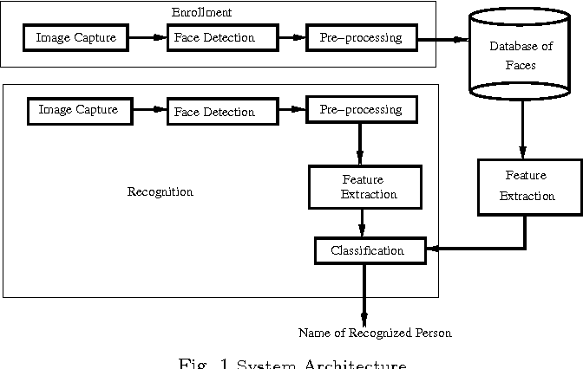

Figure 4.1.1: System architecture

**Data collection**

Collect a dataset of facial images of the faculty and students. Each person should have multiple images taken in different lighting conditions and poses.

**Haar cascade frontal face detection**

Use the Haar cascade frontal face classifier to detect faces in the input image or video stream. The Haar cascade is a machine learning-based object detection algorithm that can detect faces in real-time with high accuracy.

**Face alignment**

Use facial landmark detection to align the detected faces. This step will ensure that the face is properly oriented and aligned for recognition.

**Matching**

Match the extracted features against the database of faculty and student faces to identify the person. A threshold value can be set to decide if the match is close enough to be considered a positive match.

**Attendance management**

Keep track of attendance for each person detected and recognized in the system. This information can be stored in a database or spreadsheet.

**Automatic mail**

When a faculty member requests attendance, an automatic email can be sent to them with the attendance report.

**User interface**

Provide a user-friendly interface for the faculty to request attendance and students to register and mark their attendance.

### Data Flow Diagram:

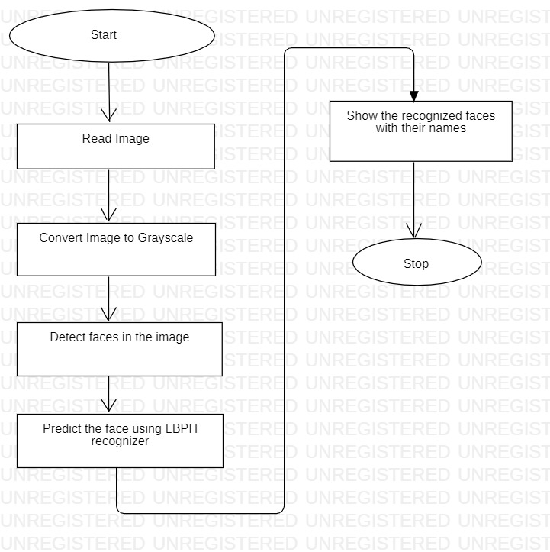

Figure 4.2.1: Data flow diagram for face recognition attendance system

Data flow diagrams, or DFDs, are graphical representations of systems that depict how data moves through various processes and data repositories. In this instance, the system reads an image, converts it to grayscale, uses Haar Cascade to find faces, uses LBP recognizer to identify those faces, and then displays the names of those faces after they have been identified. The following is an illustration of the DFD for this system:

1. start: When the user initiates the system, the process starts.
2. Read image: The system either reads an input image straight from the user's input or from a data storage.
3. Image conversion to grayscale: In order to make the face detection procedure simpler, the input image is next transformed to grayscale.
4. Utilizing Haar Cascade to detect faces in the image: The system uses the Haar Cascade classifier to find faces in the grayscale image.
5. Utilizing LBPH recognizer to predict the face: After the system finds a face, it uses LBPH recognizer to identify the face.
6. Identify the people by name and display their faces: The system shows the individuals' names and recognised faces.

### UML Diagrams:

* + 1. **Use Case Diagram:**

A use case diagram for a face recognition attendance system would depict the various actors, or users, interacting with the system and the different use cases or functions that the system can perform. Here is a possible description of such a use case diagram:

1. Actors: The primary actors in the system are the students and the administrator.
2. Use Cases: The following use cases can be represented in the diagram:
   * Check camera: The system allows students to check whether the camera is working or not.
   * Enter name id and email: The new students who want to register must enter their name, id and email for registration
   * Recognize faces: the students can mark their attendance
   * Automail: faculty can click auto mail for attendance through mail.

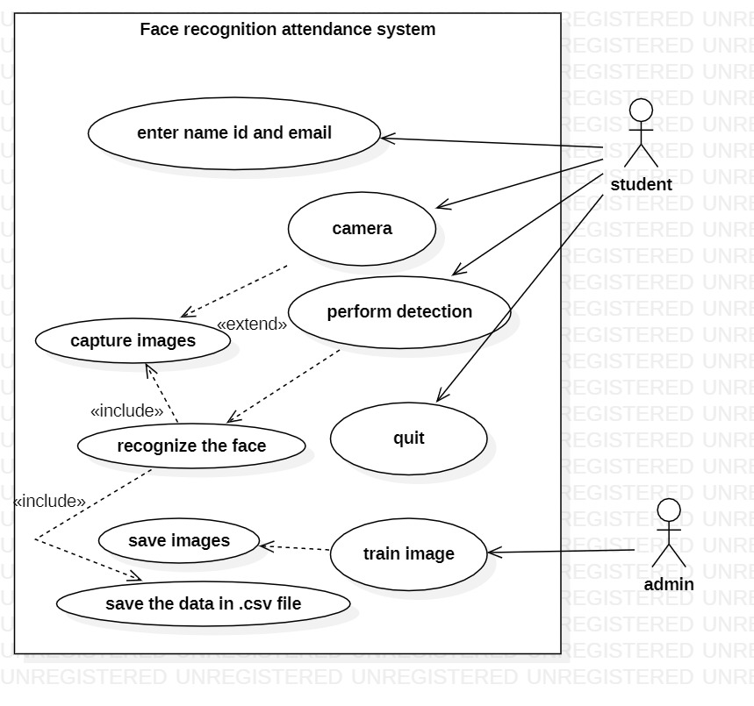

Figure 4.3.1: Use case Diagram

### Sequence Diagram:

The successive interactions between the elements or objects are depicted in the sequence diagram. This diagram is used by software developers and business experts to comprehend a system's requirements. The process can also be documented using this diagram. A different name for them is event diagrams. This diagram provides a thorough look at use cases. The amount of time an object needs to fulfil its mission is represented by activation. The consecutive tasks an object completes are indicated by a dash under the object. Sequence diagrams can use a variety of message symbols.

1. Enter name and ID: The user starts the system by entering their name and ID through the input interface.
2. Capture image: The system uses the computer's webcam to capture an image of the user's face.
3. Store the image: The captured image is then stored in the system's database for future use.
4. Recognize image: The system uses Haar Cascade and LBPH to compare the captured image with the stored images in the database to recognize the user's face.
5. Check image in folder: The system searches the database for a matching image of the user's face.
6. If true attendance should be confirmed: If a matching image is found in the database, the system confirms the user's attendance and logs the time and date of their attendance.

The sequence diagram shows the flow of actions and communication between the different components of the system during the attendance confirmation process. The user inputs their name and ID, the system captures an image of their face and stores it in the database, the system then uses Haar Cascade and LBPH to recognize the user's face, searches for a matching image in the database, and confirms their attendance if a match is found.

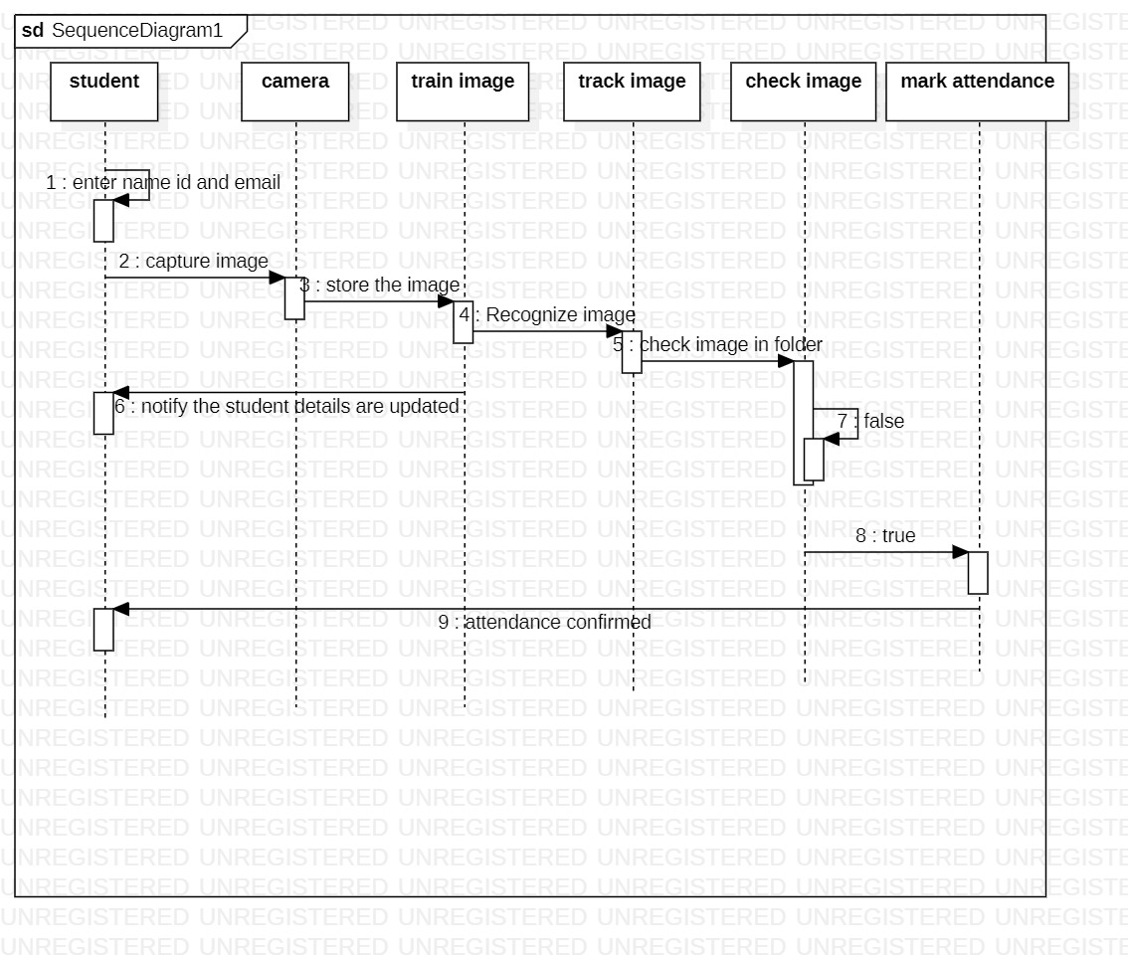

Figure 4.3.2: Sequence diagram

### Activity Diagram:

The system's activity flow from one activity to the next is shown in an activity diagram. A graphic representation of what causes a certain occurrence is an activity diagram. In UML, there are three different sorts of diagrams: interaction diagrams, behavior diagrams, and structure diagrams. The term "activity diagram" refers to a type of behavior diagram that describes an application's behavior. An activity diagram illustrates the number of decision routes that must be made when an activity is being carried out. It shows where the activity begins and where it ends. In the action box, actions are listed. Alternatives are listed using a choice box. The terms initial-state and final-state are used to denote the beginning and conclusion of an activity, respectively.

Start: The system starts.

Decision: The system checks if the student is new or not.

If new student:

* Action: The system prompts the user to enter the student's name, ID, and email.
* Action: The system captures multiple images of the student's face.
* Action: The system trains the images to create a unique face recognition model for the student.
* Action: The system saves the student's information and face recognition model in a database.
* Action: The system records the attendance of the student in a CSV file.

If not a new student:

* Action: The system recognizes the student's face using the saved face recognition models.
* Decision: The system checks if the recognized face matches any saved face recognition model.
* If match found:
  + Action: The system records the attendance of the student in a CSV file.
* If match not found:
  + Action: The system prompts the user to try again or enter the student's information as a new student.

End: The system ends.

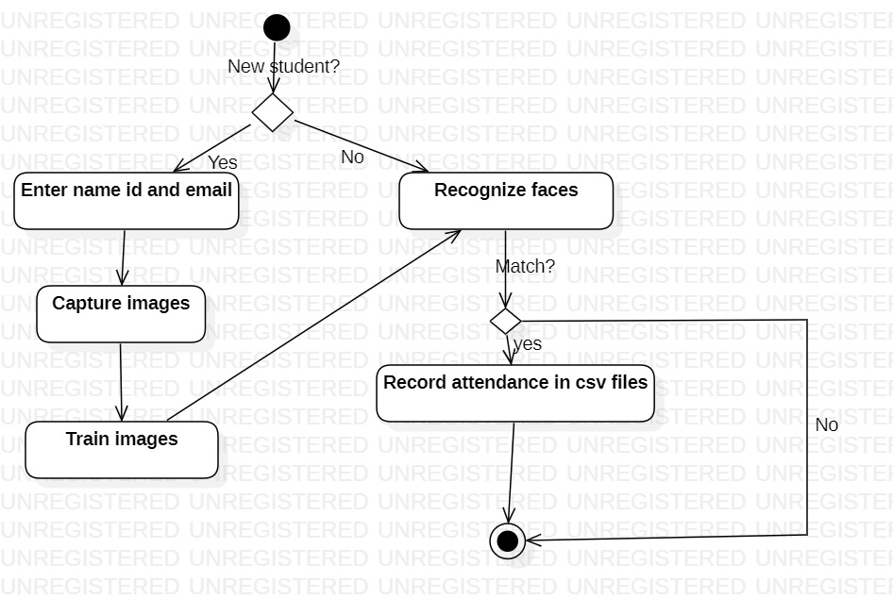

Figure 4.3.3: Activity diagram

### 4.4 Modules

### Check camera

### 1.Imports the OpenCV library. 2. Loads the face cascade classifier, which is an XML file that contains information about how to detect faces. 3. Creates a VideoCapture object that captures video from the default camera 4. Enters into an infinite loop where it reads frames from the camera. 5. Converts each frame to grayscale. 6. Detects faces in the grayscale frame using the face cascade classifier. 7. Draws a rectangle around each detected face in the original color frame. 8. Displays the color frame with the face rectangles. 9. Checks for the 'q' key to be pressed to exit the loop. 10. Releases the VideoCapture object and destroys all windows created by OpenCV.

### Train Images

### The model reads each image in the directory, converts it to grayscale, converts it to a numpy array, and extracts the ID from the filename (assuming that the ID is the integer after the first dot in the filename). The function used in the project returns two lists: faces contains the numpy arrays of the images and Ids contains the IDs associated with each image.

### Recognize faces

### The face recognizer detects faces using Haar Cascade Classifier, and recognizes the faces using Local Binary Patterns Histograms (LBPH) algorithm. Then, it matches the recognized faces with the faces in the student details CSV file to get the corresponding student name. If the match is above a certain confidence threshold, the program marks the employee as present and logs the attendance with the student ID, name, and time stamp in a CSV file named "Attendance-[Date]-[Time].csv". If the CSV file already exists, it will append new attendance data to the existing file. The program will continue to run until the user presses the 'q' key to quit.

### Automatic Mail

### The auto mail functionality is an implementation of sending an email with an attachment using the Simple Mail Transfer Protocol (SMTP). Here's what the code does: 1. The sender email address and password are defined. 2. The receiver email address is defined. 3. A message object (MIMEMultipart) is created, and the sender, receiver, and subject fields are set. 4. An attachment is added to the message object. In this case, the attachment is a CSV file. 5. The SMTP server is defined. In this case, it is Gmail's SMTP server. 6. The SMTP server connection is initiated. 7. The connection is secured using Transport Layer Security (TLS). 8. The sender's credentials are authenticated. 9. The email is sent using the sendmail() method of the SMTP server. 10. The SMTP server connection is close

# IMPLEMENTATIONS AND RESULTS

### Language / Technology used:

##### Python:

packages are readily available, and Python offers a large selection of open-source packages that make it simple to create sophisticated machine learning algorithms, such as facial recognition. OpenCV, Dlib, and TensorFlow are three common facial recognition libraries.

Python is one of the most user-friendly programming languages when it comes to both learning and using it. It has a sizable developer community that shares tools and information, and its syntax is clear and succinct.

Python is a cross-platform language, which enables it to function on a variety of operating systems, including Windows, macOS, and Linux. This makes it simple to create programmes that work across several platforms.

Scalability: Python is a very scalable programming language, which enables it to manage massive amounts of data and intricate algorithms. Because of this, it can be used to create face recognition attendance systems that need to process a lot of data.

Databases, web frameworks, and cloud services are just a few examples of the numerous technologies that Python is easily able to interact with. This enables developers to create intricate systems that are simple to integrate into current infrastructure.

All things considered, Python is a flexible and strong programming language that is suitable for creating facial recognition attendance systems as well as other machine learning applications.

**5.2 Algorithms used**

**Haar cascade:**

"Haarcascade" is one of the widely used algorithms for facial recognition. It is a quick algorithm that provides great accuracy at a lower cost in terms of computing.

It functions in four steps:

* Haar-feature choice Dark and light regions make up a Haar-like characteristic. By comparing the difference between the sum of the intensities of the bright and dark zones, it yields a single value. In order to identify an object, valuable elements must be extracted. Viola and Jones'  proposed  features are:

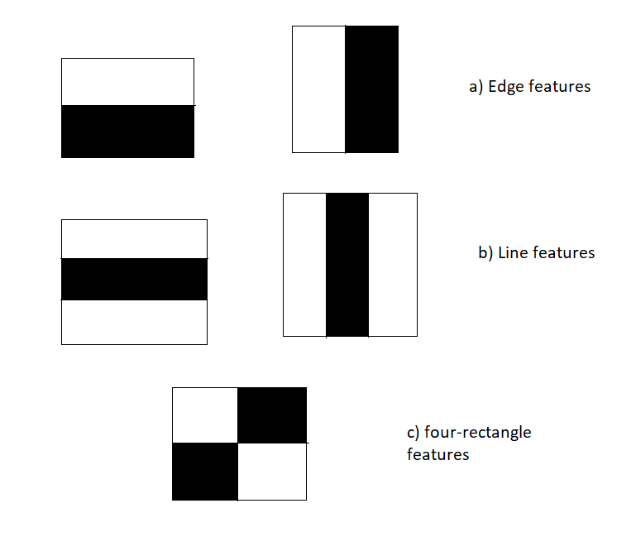

* Creation of Integral Images: A particular integral picture pixel is made up of all the pixels to its left and all the pixels to its right. Integral Images greatly shorten the time required to accomplish the operation of extracting Haar-like features, which requires computing the difference between rectangular dark and bright patches.
* AdaBoost Training: The best features are chosen by this algorithm out of all features. It creates a "strong classifier" by combining many "weak classifiers" (best characteristics). The "strong classifier" that is formed is just a linear combination of all "weak classifiers."
* Cascade Classifier: This technique combines classifiers that are progressively more complicated, such as AdaBoost, in a cascade, allowing negative input (non-face) to be swiftly discarded while devoting more processing power to promising or positive face-like regions. It greatly shortens the computation time and improves the effectiveness of the procedure.

**LBPH Algorithm**

A person's face can be recognised using the Face-Recognition method known as LBPH (Local Binary Pattern Histogram). It is renowned for its effectiveness and for being able to identify a person's face from both the front and the side.

1.The LBPH uses the following four parameters:

* Radius: The radius represents the area surrounding the centre pixel and is used to construct the circular local binary pattern. Typically, it is set to 1.
* Neighbours: The quantity of sample points used to create the local binary pattern in a circle. Remember that the computational cost increases as the number of sample points increases. Usually, it is set to 8.
* Grid X: the quantity of cells arranged horizontally. The resulting feature vector has a higher dimensionality the more cells there are and the finer the grid is. Usually, it is set to 8.
* Grid Y: the quantity of cells arranged vertically. The resulting feature usually, it is set to 8.

2. Training the Algorithm:

The first step is to train the algorithm. We must use a dataset containing the facial photographs of the persons we wish to identify in order to accomplish this. For each image, we must additionally include an ID (which may be a number or a person's name), which the algorithm will use to identify an input image and provide an output. The same ID must appear on all images of the same person. Let's look at the LBPH computational steps with the training set already created.

3. Applying the LBP operation:

The initial computational phase of the LBPH is to produce an intermediate image that, by emphasizing the face features of the original image, more accurately describes it. The method does this by utilizing a sliding window idea based on radius and neighbors.

The image below demonstrates this process: 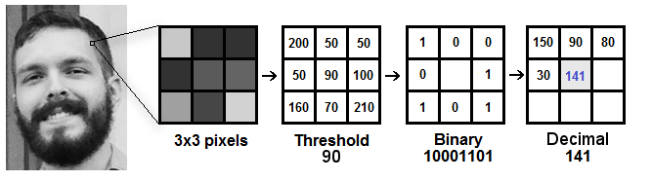

Let's break it down into multiple manageable phases based on the illustration above so that we can understand it quickly:

* Consider a grayscale image of a face.
* This image can be partially obtained as a 3x3 pixel window.
* It can also be shown as a 3x3 matrix with each pixel's intensity (0–255) in it.
* Next, the threshold must be determined by using the matrix's centre value.
* To specify the new values from the eight neighbours, use this value.
* We set a new binary value for each neighbour of the threshold's core value. We set the threshold to be 1 for values that are equal to or higher than it, and 0 for those that are below.
* The center value will now be ignored, leaving the matrix with only binary values. Line by line, we must concatenate every binary value from every place in the matrix to create a new binary value (for example, 10001101).
* The central value of the matrix, which is actually a pixel from the original image, is then set to this binary value after being converted to a decimal value.
* After this process (the LBP technique), we obtain a new image that more accurately captures the qualities of the original image.

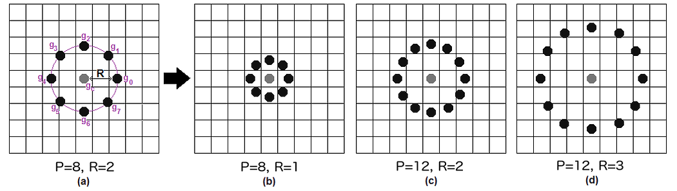

Bilinear interpolation can be utilized to accomplish this. If a data point lies between two pixels, it estimates the value of the new data point using the values from the four (2x2) closest pixels.

4. Extracting the Histograms: Using the image created in the previous step, we can now divide the image into different grids using the Grid X and Grid Y parameters, as seen in the following image:

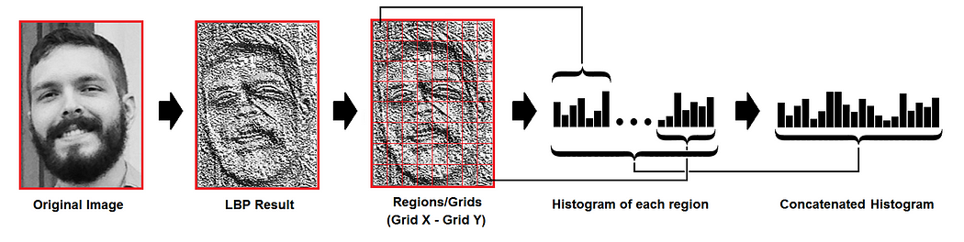

We can extract the histogram of each region from the image above by doing the following:

* Each histogram (from each grid) will only have 256 locations (0–255) reflecting the occurrences of each pixel intensity because our image is grayscale.
* The next step is to combine each histogram into a single, larger histogram. In the event that we have 8x8 grids, the final histogram will include 16.384 locations (8x8x256). The properties of the original image are reflected in the final histogram.

5. Using the algorithm to recognize faces:

The algorithm has already been trained for this phase. Each histogram produced serves as a representation of one of the training dataset's images. In order to build a histogram that accurately depicts an image, we repeat the process for a fresh image after receiving an input image.

* Therefore, all that is required to locate the image that corresponds to the input image is to compare two histograms and return the image with the closest histogram.
* The distance between two histograms can be calculated using a variety of methods, such as the Euclidean distance, chi-square, absolute value, etc. Based on the following formula, we can apply the well-known Euclidean distance in this example:

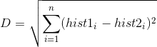

* The ID from the image with the closest histogram is the result of the method. The calculated distance, which can be utilized as a "confidence" metric, should also be returned by the algorithm. Note that despite what the word "confidence" implies, lower confidence levels are preferable because they indicate a closer gap between the two histograms.
* The algorithm's accuracy in identifying the image can then be automatically determined by applying a threshold and 'confidence'. If the confidence is less than the specified threshold, we can assume that the algorithm has recognized the object successfully.

### Sample Code:

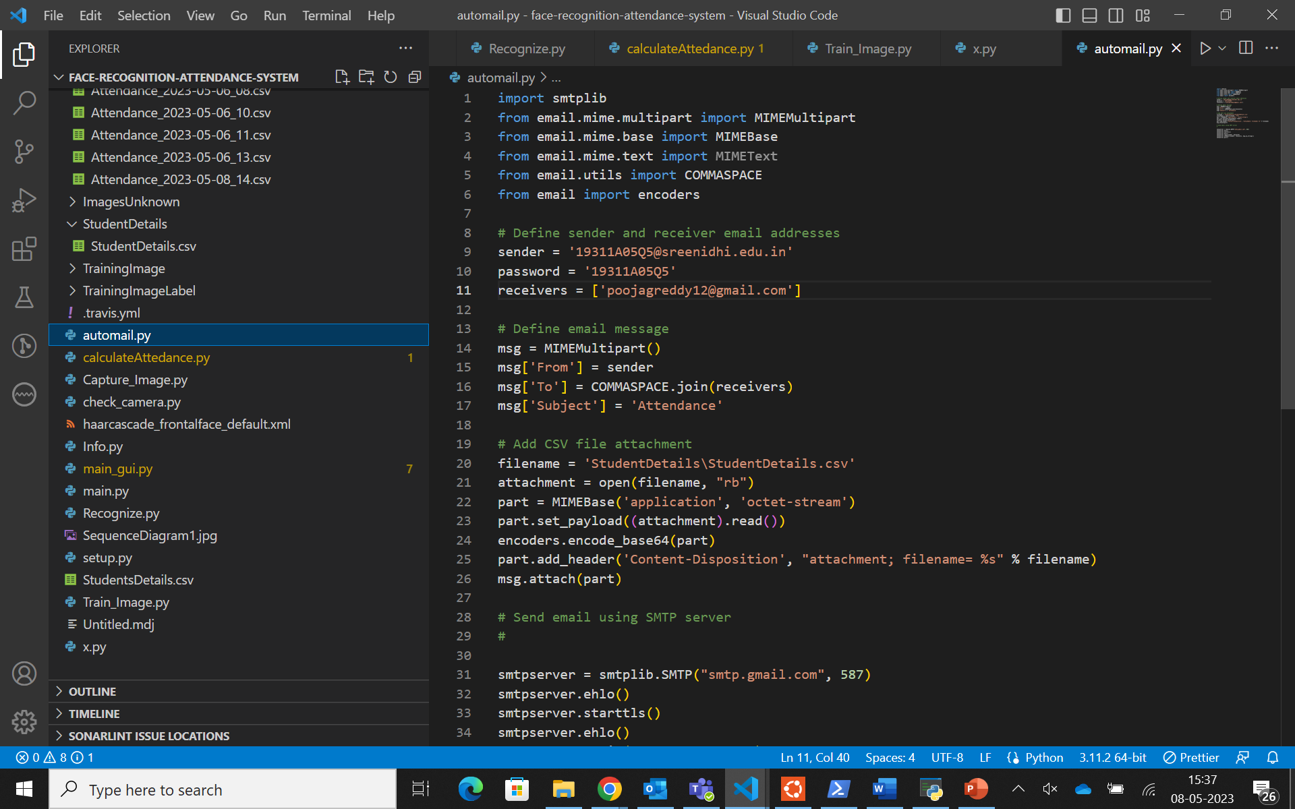

Figure 5.2.1 automail.py

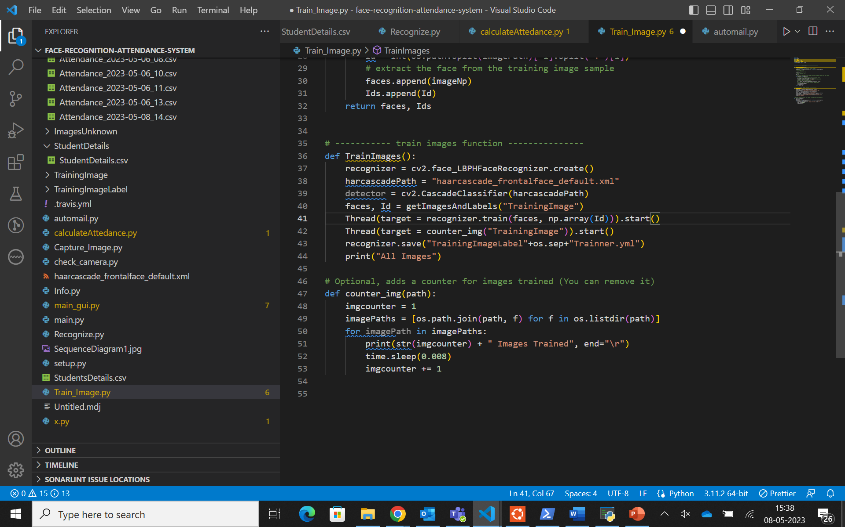

Figure 5.2.2 Train_Image.py

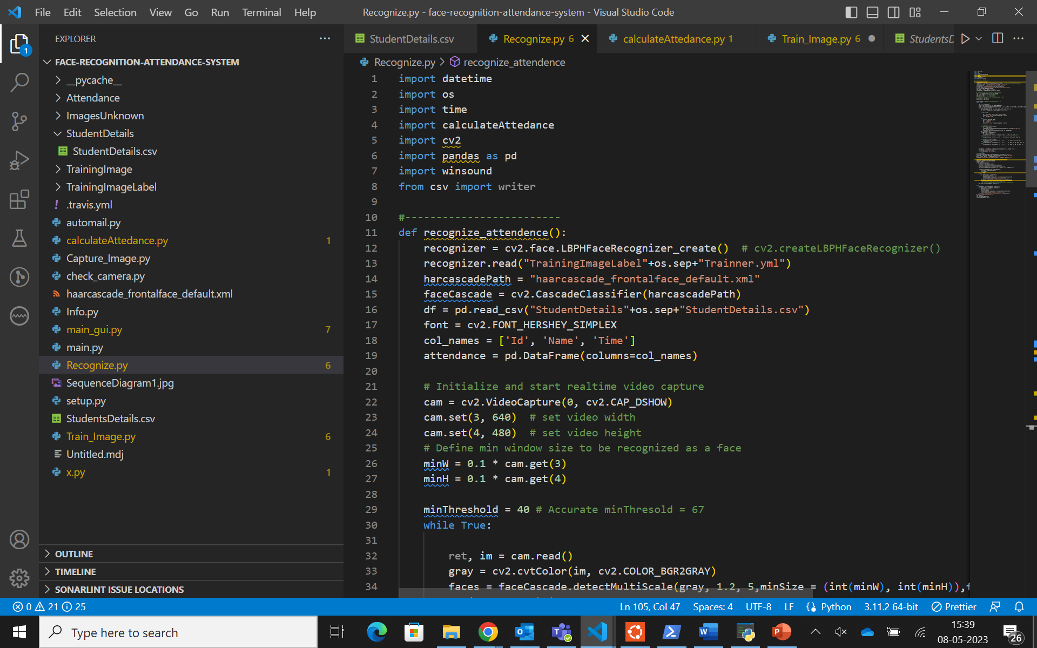

Figure 5.2.3 Recognize.py

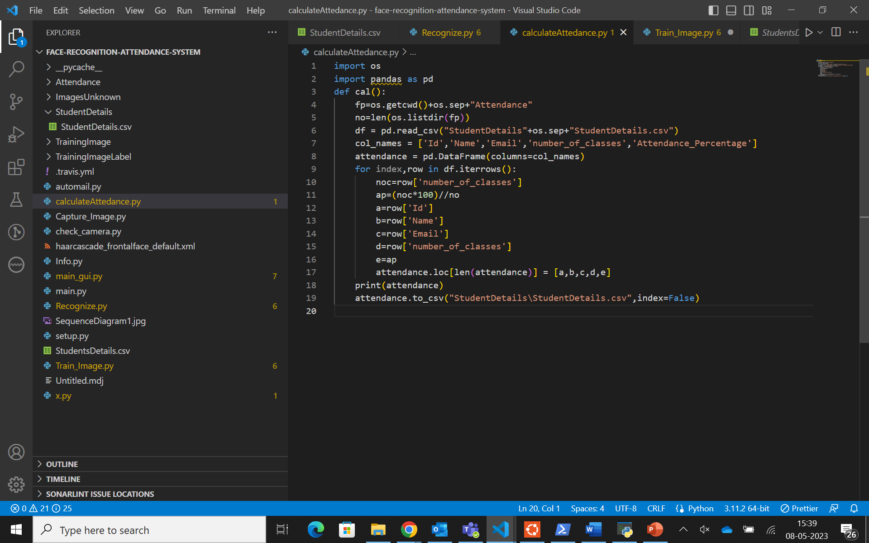

Figure 5.2.4 calculateAttendance.py

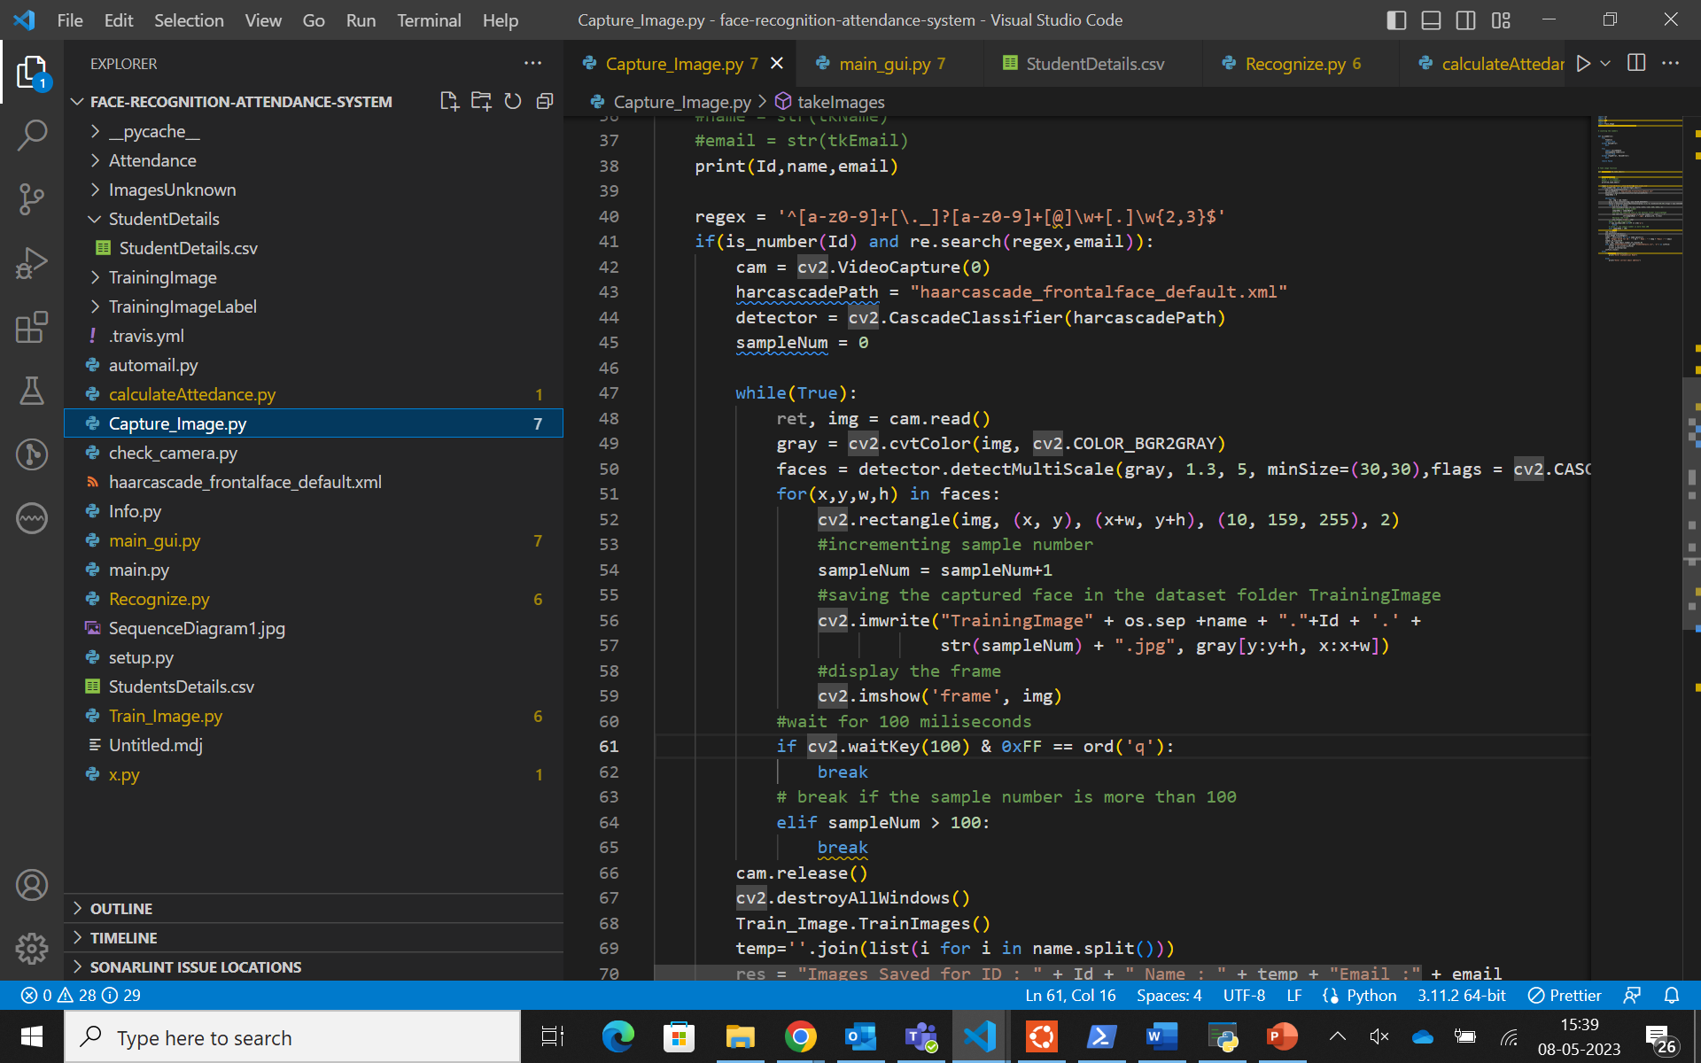

Figure 5.2.5 capture_Image.py

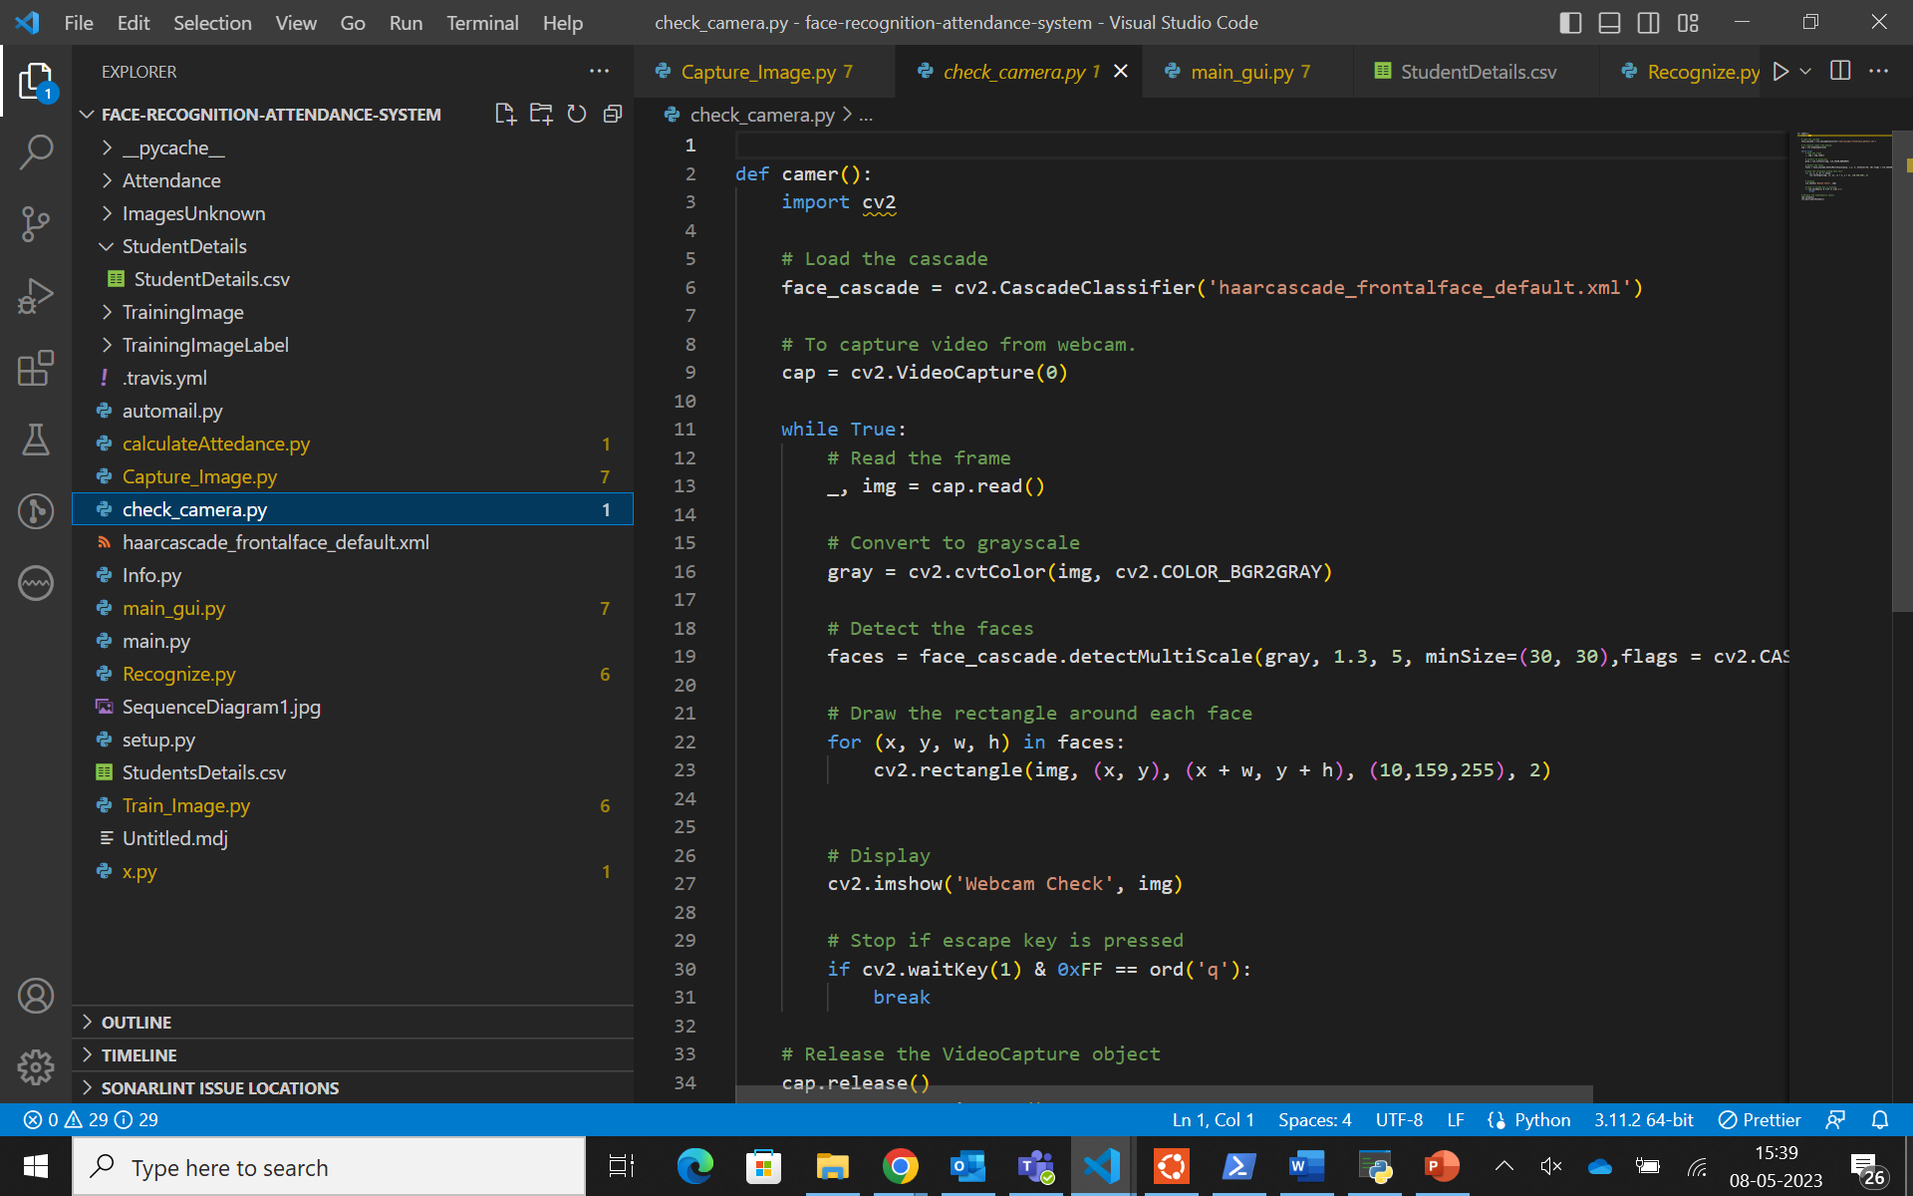

Figure 5.2.6 check_camera.py

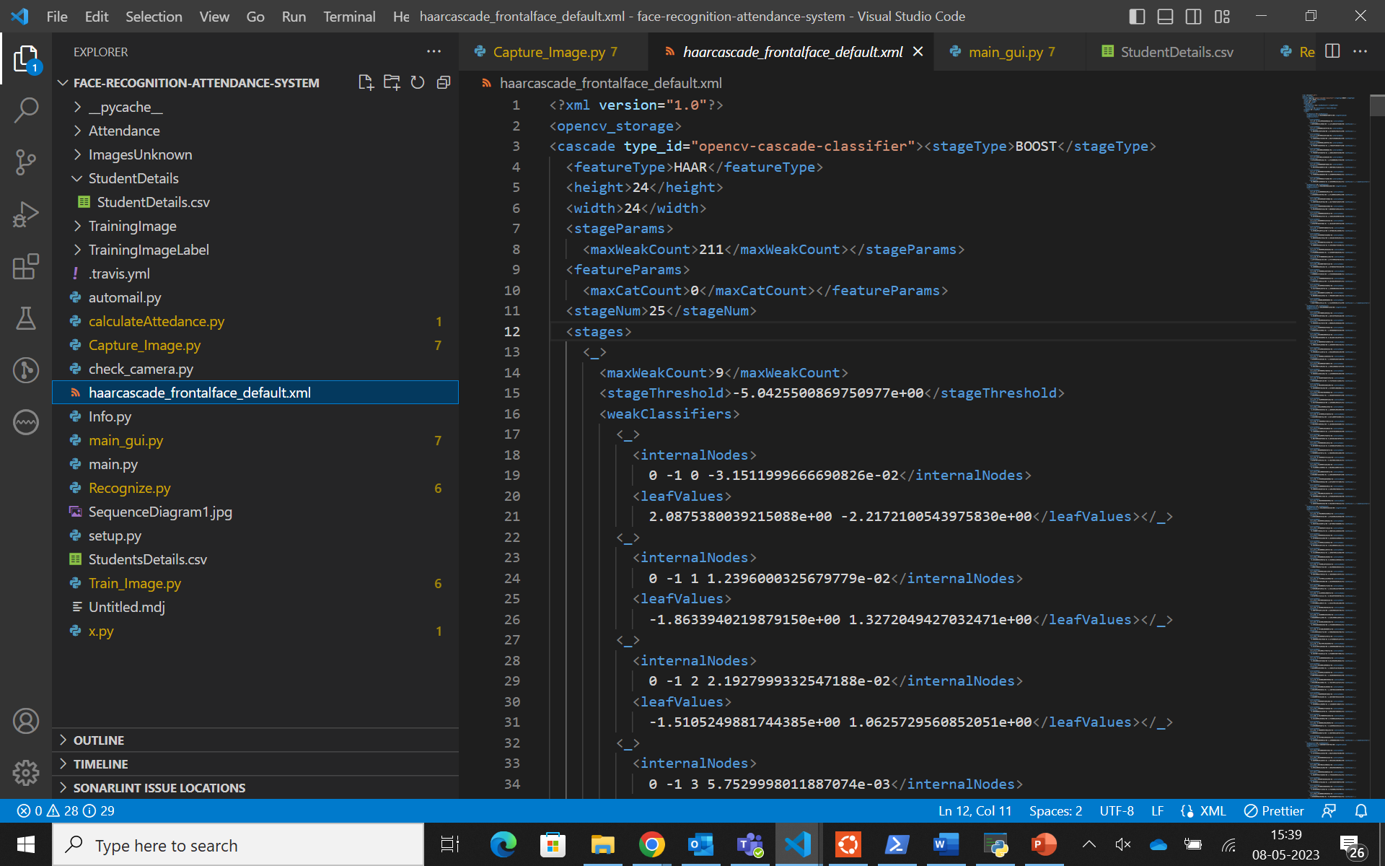

Figure 5.2.7 haarcascade_frontalface_default.xml

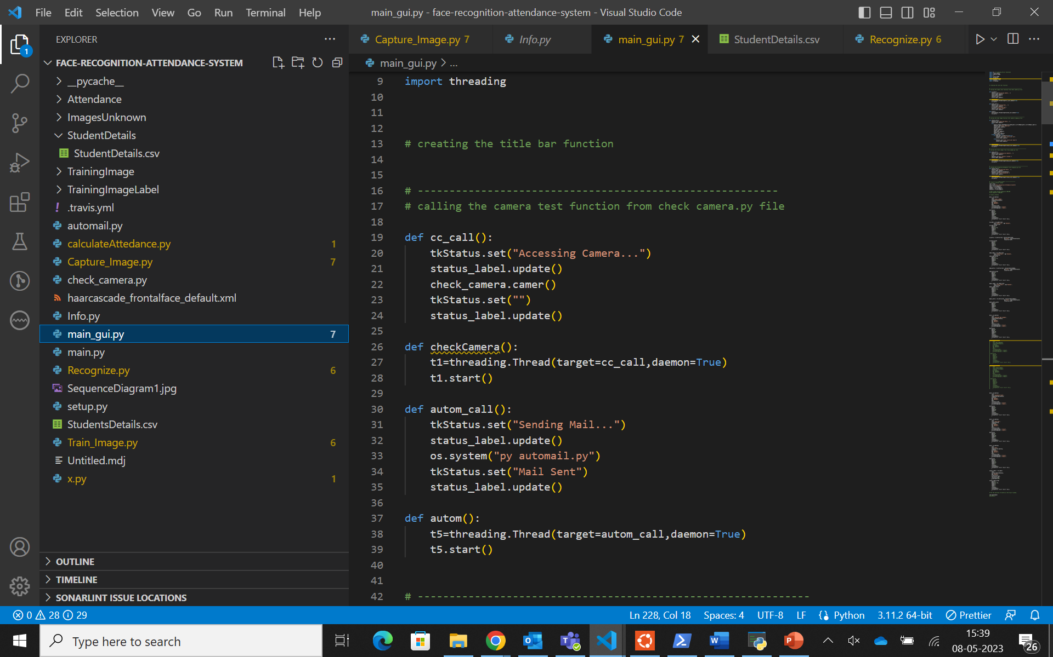

Figure 5.2.1 main_gui.py

### Output Screens:

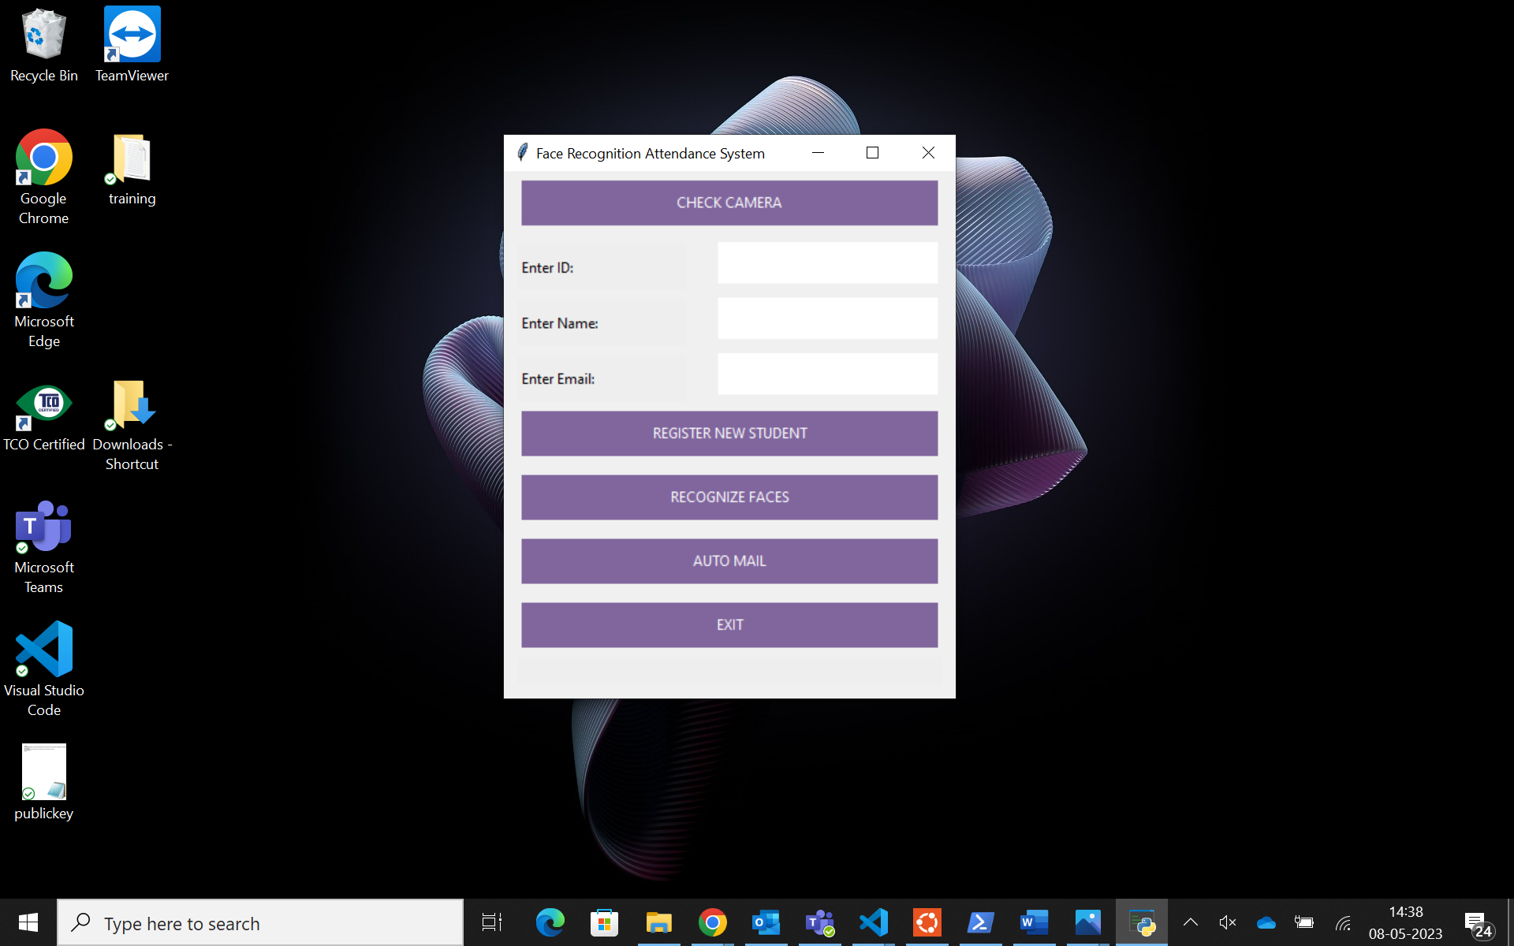

Figure 5.3.1: Graphical User Interface

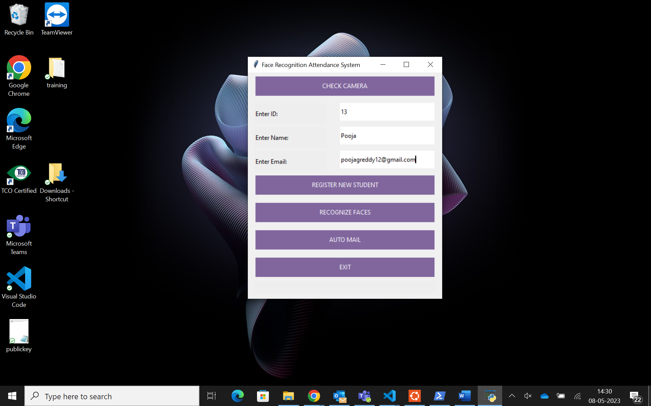

Figure 5.3.2: Enter Details for Registering new student

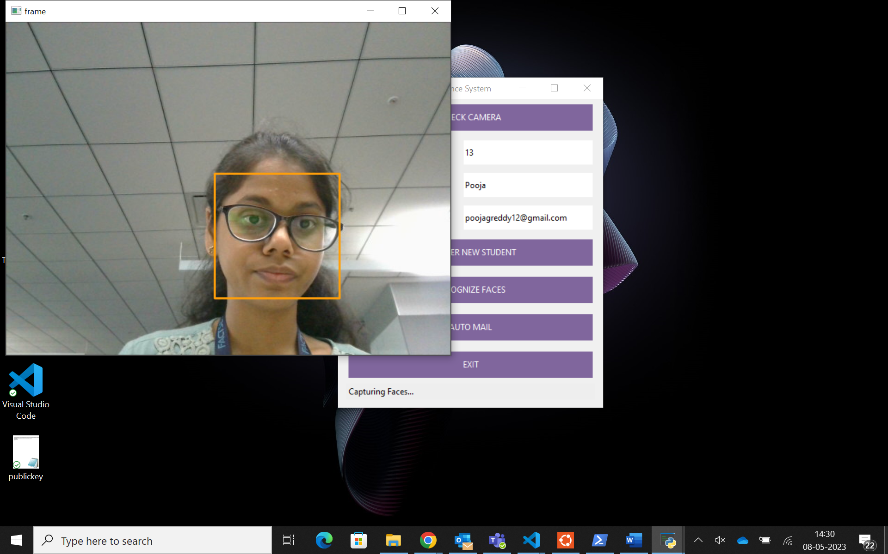

Figure 5.3.3: Capturing faces for new student registration

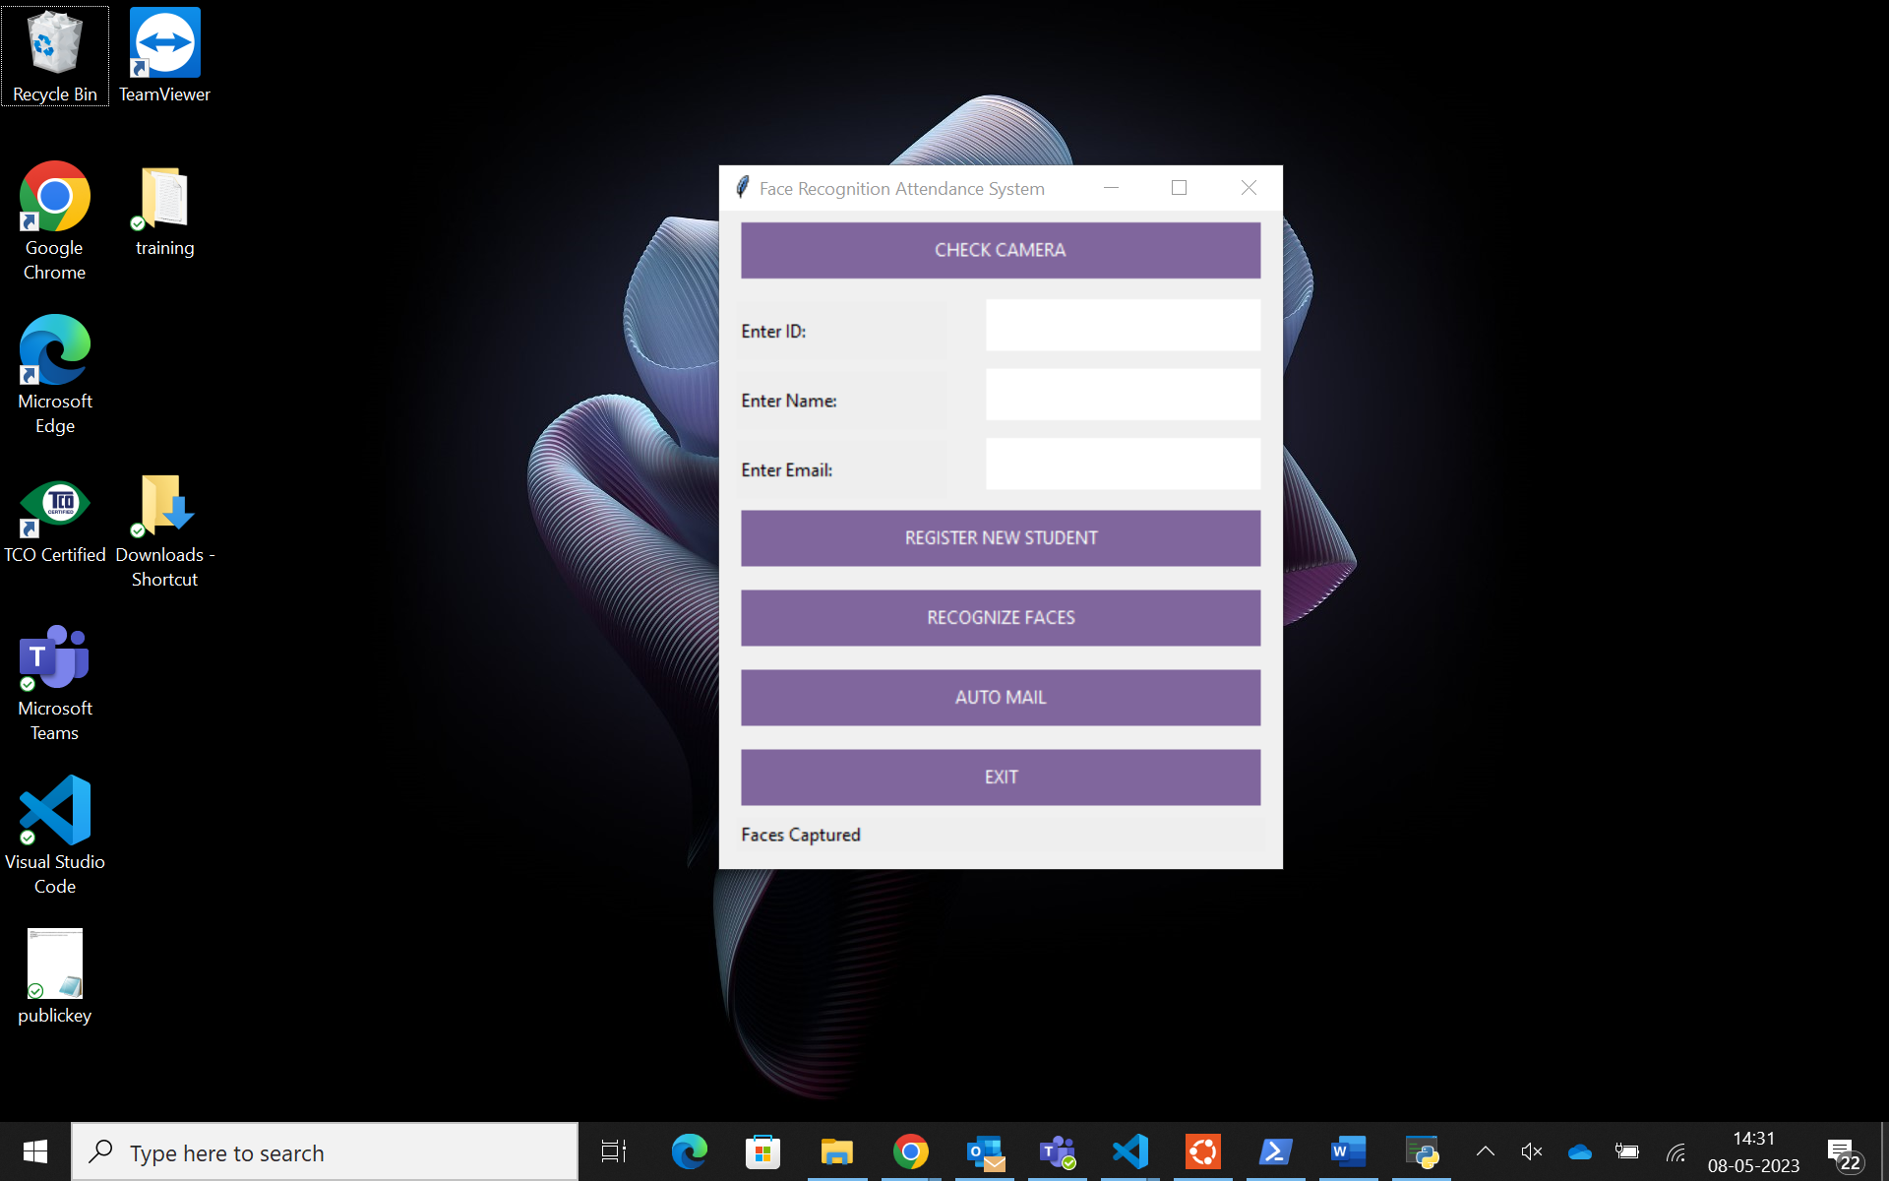

Figure 5.3.4: New student registration is complete and model has been trained

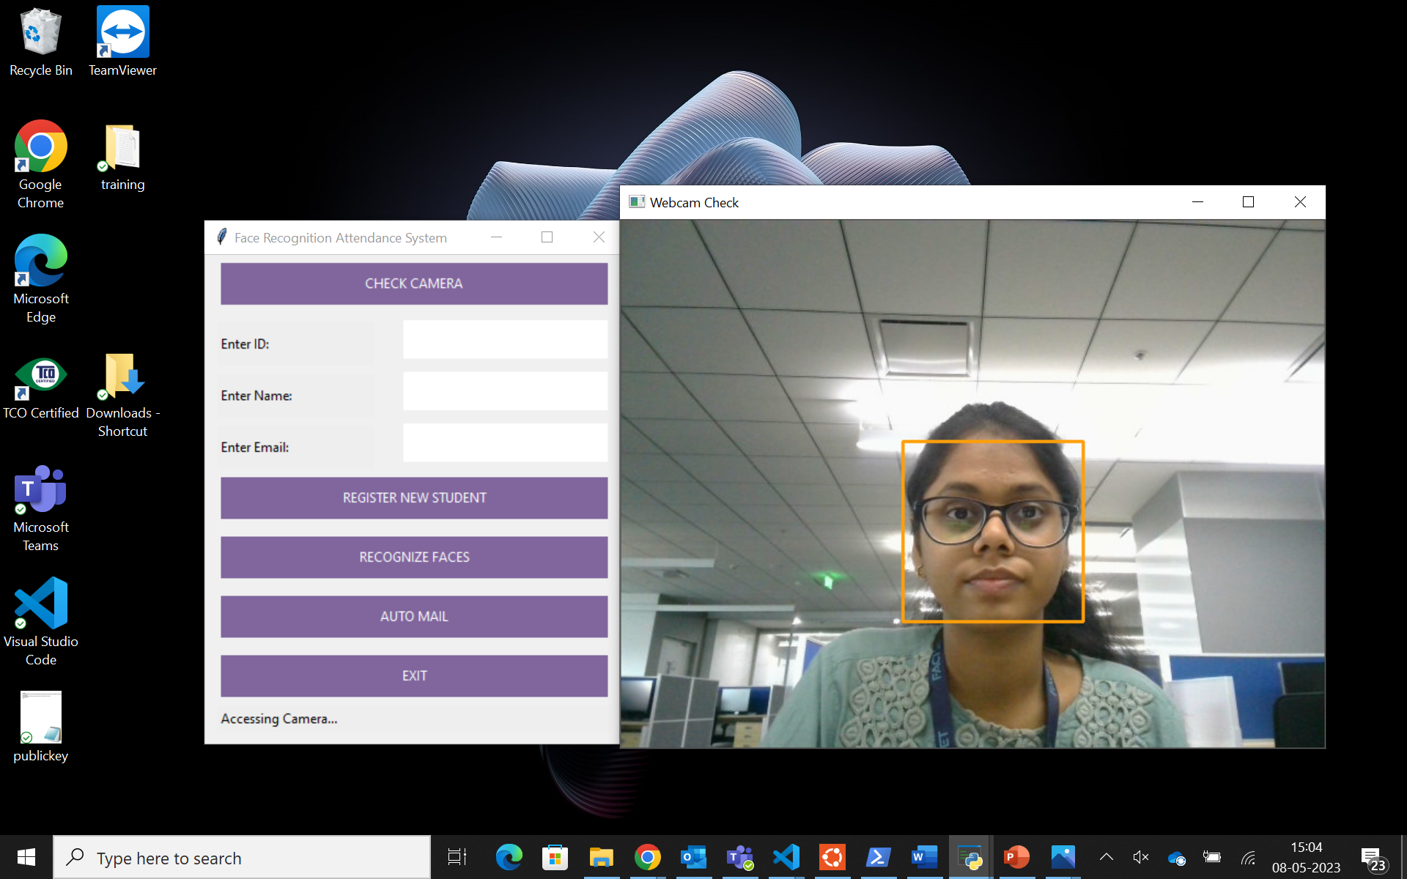

Figure 5.3.5: Check camera

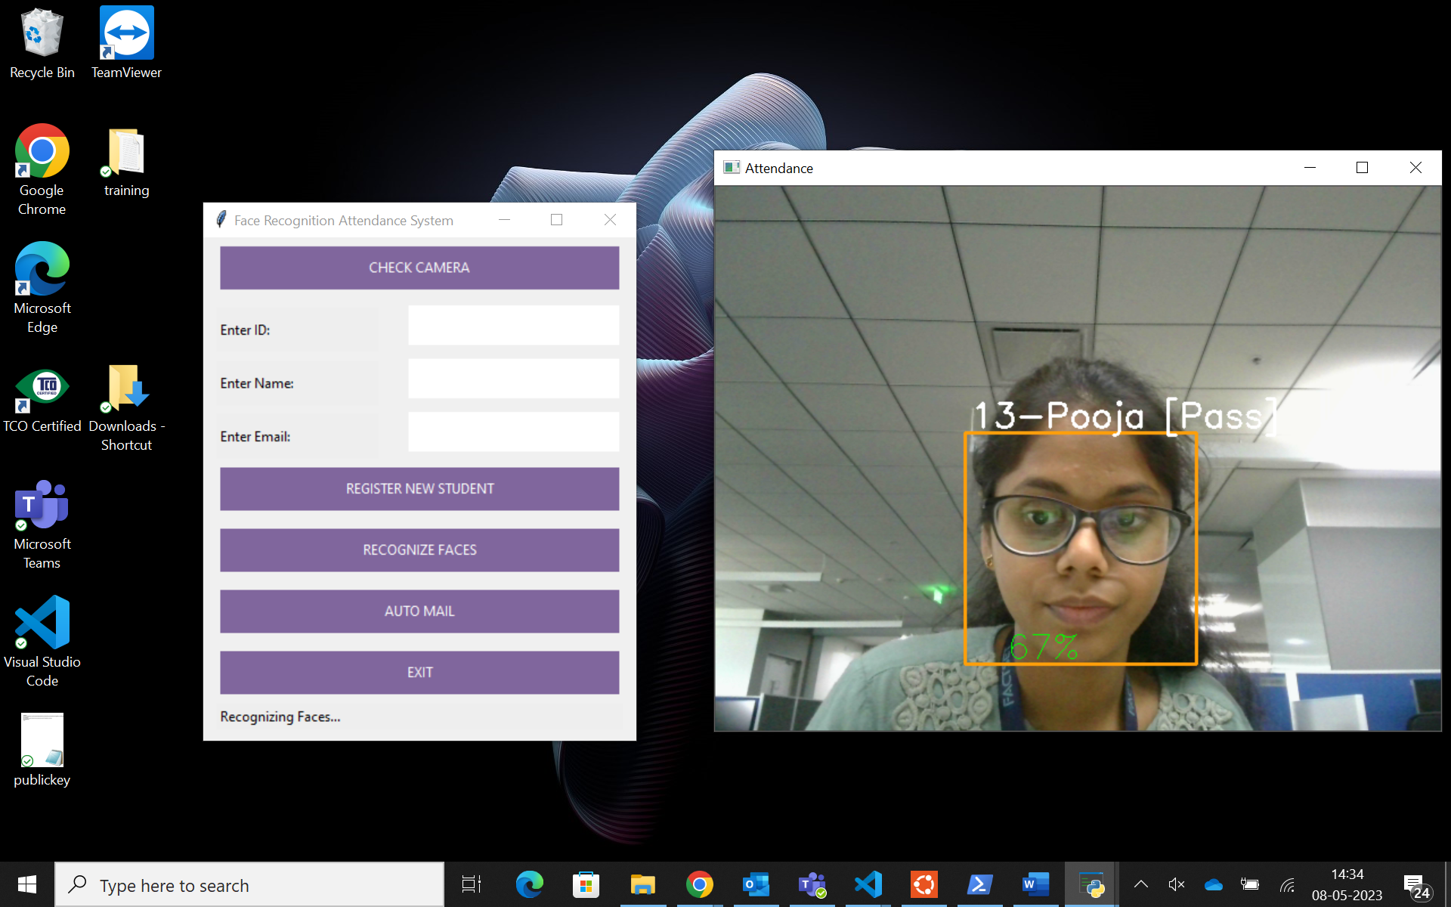

Figure 5.3.6: Attendance

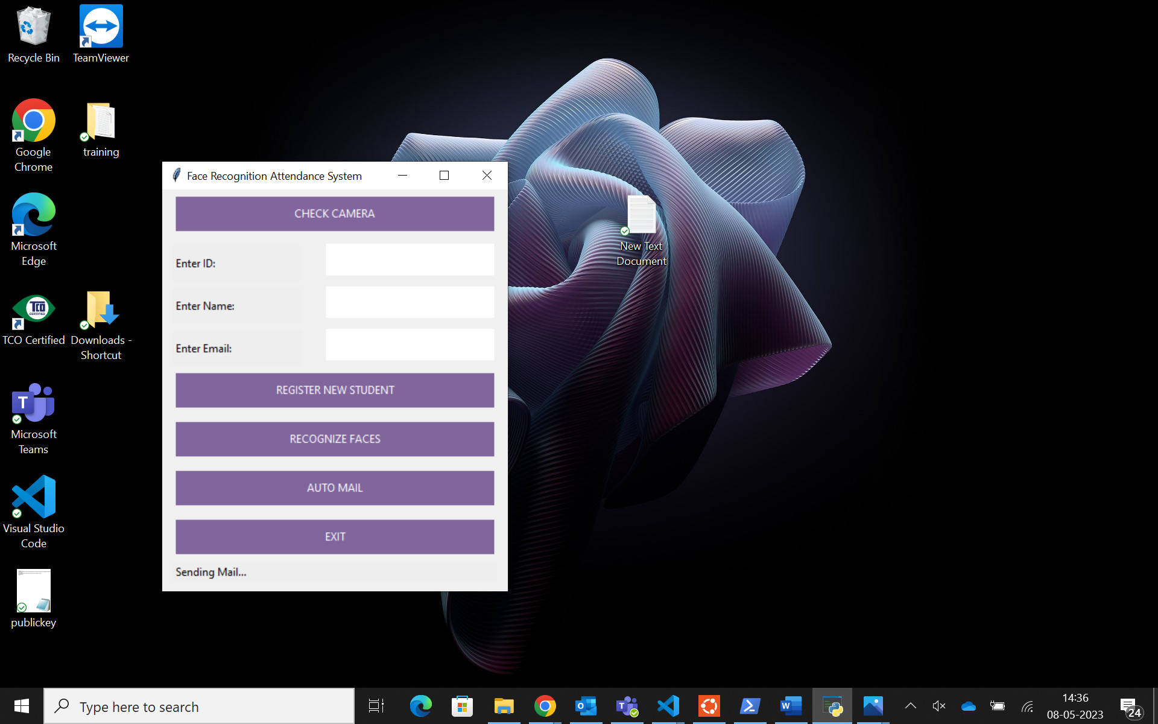

Figure 5.3.7 Sending mail using auto mail

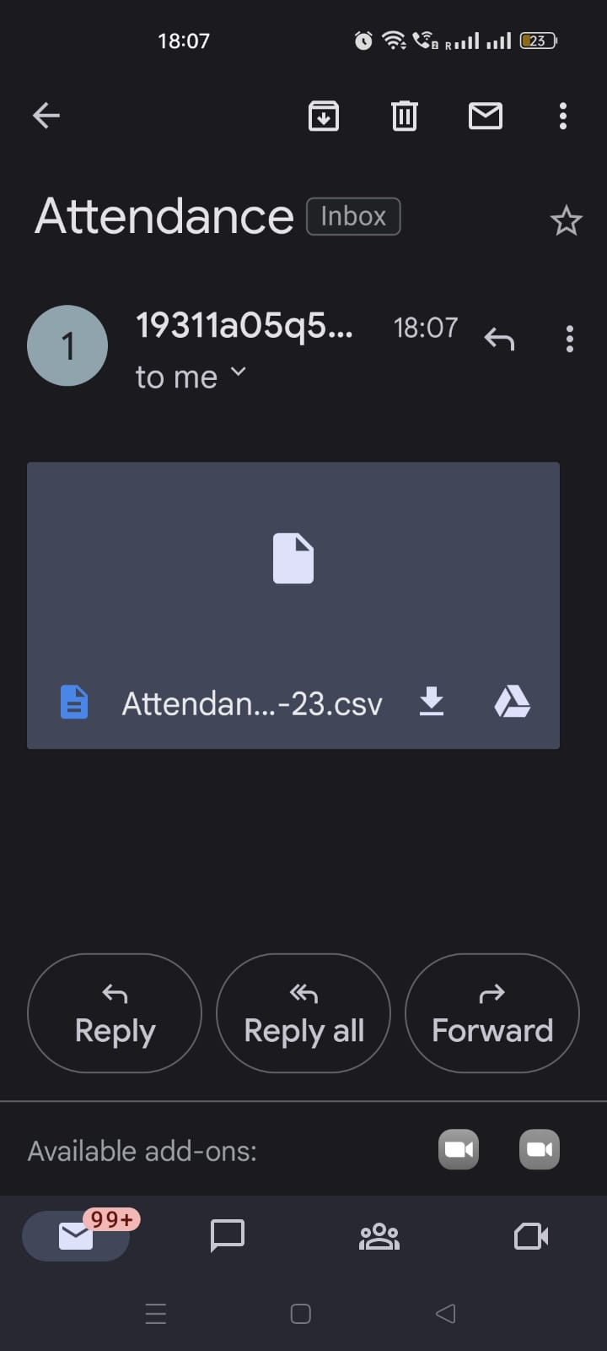

Figure 5.3.8: Mail sent through auto mail

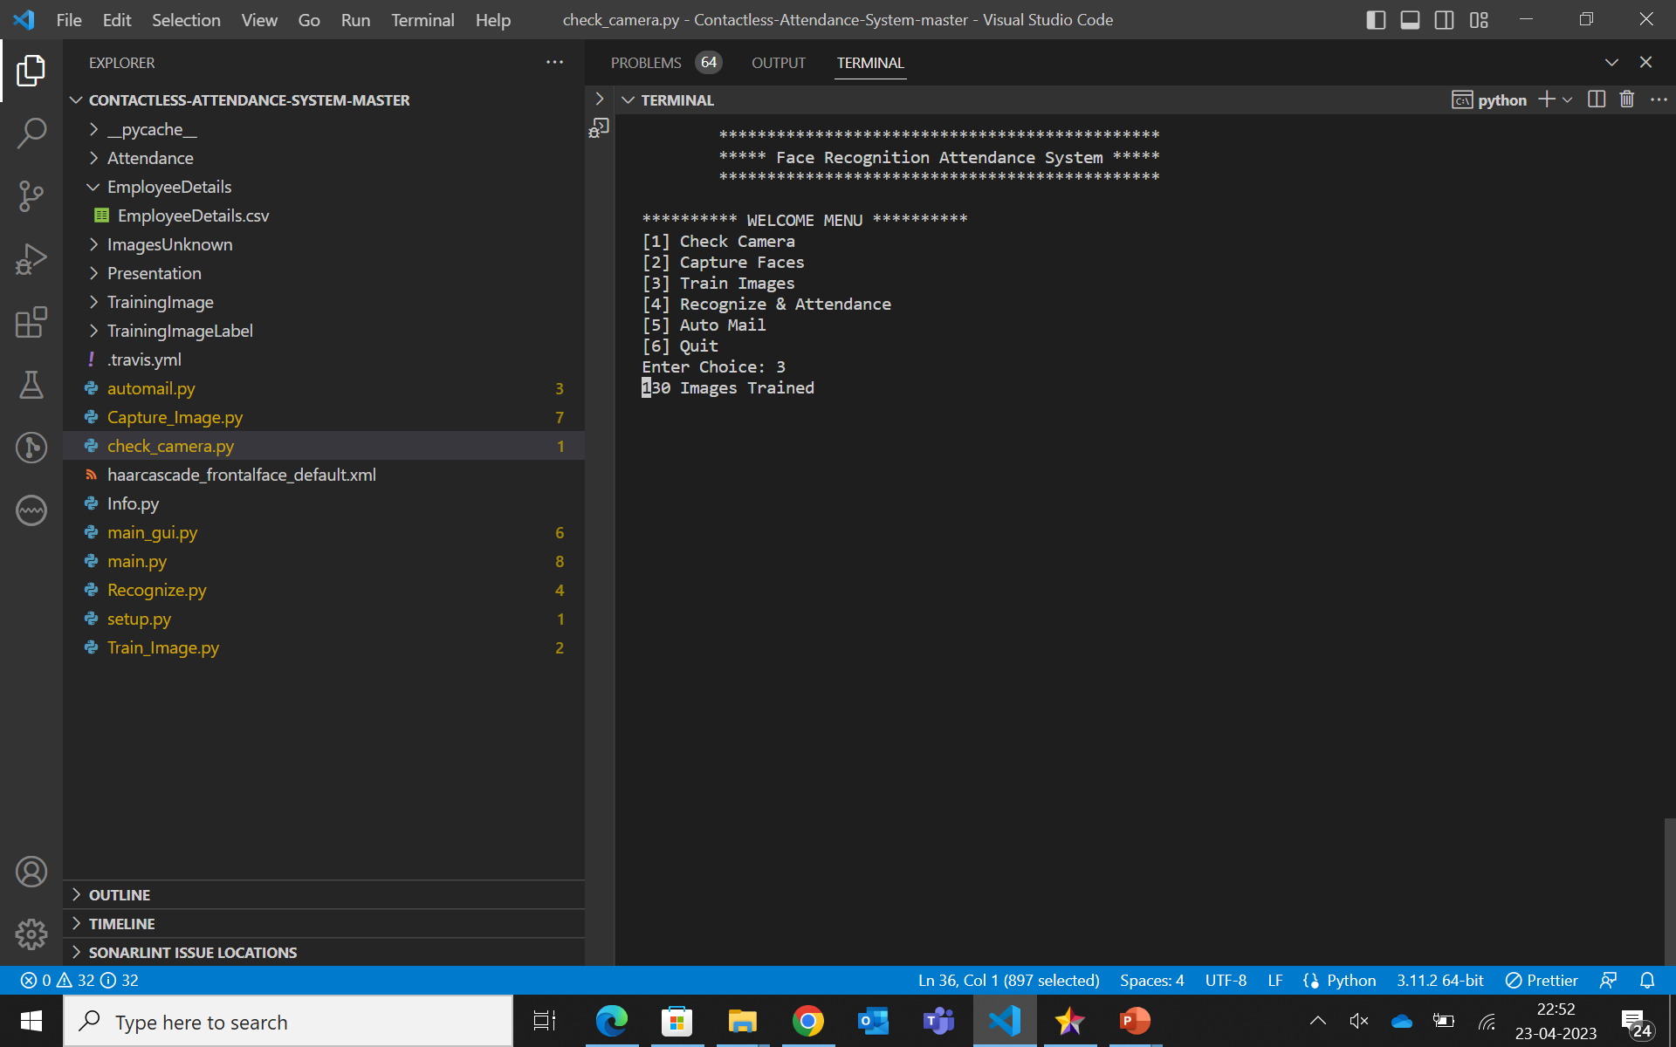

Figure 5.3.9: Command line interface



Figure 5.3.10: Student attendance

# TESTCASES

The following section elucidates on the types of testing used to test the various functionalities of this application, their details and associated test cases used to evaluate the efficacy of modular functions of the application.

### Types of Testing

The goal of testing is to identify errors. The most popular method for trying to identify every flaw or weakness in a work item is testing. It provides a mechanism for evaluating the value of components, sub congregations, gatherings, as well as a finished item. The goal is to ensure that the software framework fits its requirements and client assumptions and doesn't fail in an unpleasant fashion. It is the most popular method of programming practise. There are various test types. Every test type favours a specific testing prerequisite.

##### TYPES OF TESTS

**Unit testing:**

Unit testing involves the design of tests that confirm the internal logic of the program is operating correctly and that program inputs result in meaningful outcomes. The internal code stream and all decision branches must be approved. It is the application's individual programming units being tested. It is completed once a single unit has reached its full potential before uniting. This is an intrusive underpinning exam that relies on knowledge about its development. Unit tests carry out fundamental tests at the component level and examine a certain business cycle, application, and framework configuration. Unit tests ensure that every noteworthy business transaction executes exactly as specified by the recorded data, has clearly characterised inputs, and contains anticipated consequences.

##### Integration testing:

Combination tests are designed to evaluate if integrated programming components truly function as a single program. Testing is event-driven and more concerned with the core outcome of screens or fields. Integration tests show that even though the components were fulfilled independently, as effectively demonstrated by unit testing, the combination of components is correct and stable. Mix testing is specifically designed to find problems that arise from the blending of elements.

##### Functional test:

Functional tests provide deliberate evidence that the capabilities being tested are available in accordance with the technical and business requirements, framework documentation, and user guides. Practical test organisation and association is based on requirements, essential skills, or distinctive experiments. Similarly, testing should take into account effective inclusion relating to recognise Business process streams; information fields, established procedures, and progressive cycles. Additional tests are identified before utilitarian testing is complete, and the success value of the current is not predetermined. Focus of functional testing is on the following areas:

Valid Input : identified classes of valid input must be accepted.

Invalid Input: identified classes of invalid input must be rejected.

Functions: identified functions must be exercised.

Output: identified classes of application outputs must be exercised. Systems/Procedures: interfacing systems or procedures must be invoked.

##### System Test:

System testing ensures that the integrated programming framework as a whole complies with requirements. It evaluates a design to provide predictable and unsurprising results. The design-arranged framework combination test serves as an example of framework testing. Testing a framework relies on process streams and representations, placing emphasis on pre-driven process linkages and combination focuses.

##### White Box Testing:

White box testing is a type of testing where the person analysing the product is aware of some of its internal workings, as well as its design, language, and perhaps even its rationale. It is rationale. used to test whether certain areas are inaccessible from a black box level.

##### Black Box Testing:

Black box Testing involves using the product while knowing very little about its internal workings, architecture, or language. Black box tests, like the majority of other types of tests, should be created from a comprehensive source document, such as a detail or requirements report. It is challenging since the test product is treated like a mysterious black box. It is opaque to "see" into.

The test asks for inputs, and the results are produced without consideration for how the thing functions.

##### Features to be tested:

##### 

1. Face detection and recognition accuracy: The accuracy of the face detection and recognition algorithm should be tested under different lighting conditions, angles, and poses.
2. Registration process: The registration process should be tested to ensure that it is user-friendly and easy to use. The system should be able to capture high-quality images of the students' faces and store them securely.
3. Attendance marking: The system should accurately mark the attendance of each student present in the classroom. The accuracy should be tested under different lighting conditions and with students wearing glasses, hats, or scarfs.
4. Auto mail: The system should be able to automatically send email notifications to students and teachers regarding attendance records. The email notifications should be tested to ensure that they contain accurate information and are delivered promptly.

##### Integration Testing:

The gradual integration testing of at least two coordinated programming components on a single stage is known as programming incorporation testing, and it is done to address disappointments brought on by interface failures.

The task of the joining test is to carefully examine any parts or programming applications, such as components in a product framework or - moving ahead - programming applications that enable error-free communication at the organizational level.

Test Results: All of the above-mentioned experiments were successful. No abnormalities were noticed.

##### Acceptance Testing:

Client Acceptance Testing is a fundamental phase of every project and necessitates substantial client cooperation. Additionally, it ensures that the framework satisfies the requirements of utility.

Test Results: All of the above-mentioned experiments were successful. No flaws were discovered.

**TEST DESIGN:**

* + - * To make sure all criteria are met, the tester will comprehend each criterion and create a corresponding test case.
      * As part of the traceability matrix, each test case will be mapped to a use case and a set of requirements.
      * The Business Analyst will analyze each test case, and after the assessment, the flaws are noted and communicated to the test team. The testers will revisit the defects found in the evaluation before obtaining final clearance and sign-off.
      * During the planning stage, testers will create step-by-step test cases using the prototype, use case, and functional specification.
      * The test case will be changed as necessary as the testers keep a tracker sheet for clarifications, which they will communicate with the requirements team on a regular basis. Clarifications may occasionally result in change requests, requests that are out of scope or that don't detail implicit needs.
      * Business Analysts would send letters confirming their approval of the test scenarios.
      * If the test case undergoes any more modifications, they will be instantly updated.

##### TEST EXECUTION:

Testers will begin an exploratory test of the application to make sure it is stable for testing when all test cases have been approved and the test environment is ready for testing.

Test cases are given directly to each tester. In order to update test status and report bugs, testers must have the appropriate access to the testing environment. If there are any problems, they will be escalated to the Test Lead, who will then contact the Project Manager. Exploratory testing showstoppers will be escalated to the appropriate development SPOCs for repairs. Every tester runs the execution step by step and updates the execution status. For each phase, the tester enters a Pass or Fail status. Tester will create a Run chart that includes day-by-day execution information. If there are any errors, flaws will be reported in accordance with severity recommendations in the program, outlining the steps to simulate and, if necessary, including screenshots. All stakeholders will receive daily reports on the execution status of the tests and the defect situation. To guarantee that all test cases are run with a pass/fail category, the testing team will take part in defect triage sessions. After checking with the test lead, any faults that are not steps but might be outside the test steps need to be recorded and mapped to the test case level or the exact step where the issue was found. Until all test cases have been fully completed with a Pass/Fail condition, this process is repeated. Any flaws that have been corrected will be tested during the following cycle, and results will be updated as needed. Final approval or project completion will occur in accordance with the process.

### 

### List of Test Cases

The following is a list of test cases used to perform functional testing at various stages of the project, in order to evaluate the efficacy of each module’s behavior, and make Immediate corrections upon identification of bugs.

|  |  |  |  |  |  |
| --- | --- | --- | --- | --- | --- |
| SI.No | Action | Inputs | Expected  Output | Actual Output | Test Result |
| 1 | Capture Images | A Person’s Face | Images are captured and stored | Images are captured and stored | Pass |
| 2 | Train the image Dataset | Stored images of face | Create histograms and store values | Create histograms and store values | Pass |
| 3 | Face Recognition | A live stream of a person’s face | Name of detected person is displayed on the screen | Name of detected person is displayed on the screen | Pass |
| 4 | Update attendance for multiple people at once | Multiple faces from a live  video stream | Update attendance for all faces detected | Update attendance for all faces detected | Pass |
| 5 | Face detection | A Person’s Face | Rectangle frame around the face | Rectangle frame around the face | Pass |
| 6 | Automail |  | Mail is sent to the respective faculty | Mail is sent to the respective faculty | Pass |

Table 6: Test cases

# CONCLUSION

In this project, we successfully developed a face recognition-based attendance management system. In our system for managing attendance, students are first registered using the "Register New Student" feature; attendance may then be added using the "Recognise Faces" feature; and if the faculty wants an attendance file, they can simply use the "Automail" option, which sends mail automatically with just one click. We have used the Haar cascade algorithm for face detection and the local binary histogram pattern algorithm for face recognition.

# FUTURE SCOPE

By including new features for teachers and students, this project has the potential to evolve further in the future. This project has a huge range of future potential. Some of these include the following: improving security; using them in large educational institutions; tracking staff attendance; and building systems entirely on the web. Additionally, the photos of unauthorized individuals can be effectively preserved and displayed in the system for increased security. Less storage space is needed if the number of training photos decreases. This can be done by removing multiple pictures of the same person or pictures with identical embeddings. Retraining the classifier exclusively for the newly added photos can cut down on training time. A function that automatically sends an employee a warning if his attendance or working hours fall below the threshold can be added. In order to improve the recognition model's accuracy, incorrectly labelled photos can be introduced to the training dataset.